**JS Advanced Regular Exam – 19 Feb 2022**

**Problem 1. Ski Lift**

**Environment Specifics**

Please be aware that every JS environment may **behave differently** when executing code. Certain things that work in the browser are not supported in **Node.js**, which is the environment used by **Judge**.

The following actions are **NOT** supported:

* **.forEach()** with **NodeList** (returned by **querySelector()** and **querySelectorAll()**)
* **.forEach()** with **HTMLCollection** (returned by **getElementsByClassName()** and **element.children**)
* Using the **spread-operator** (**...**) to convert a **NodeList** into an array
* **append()** in Judge (use only **appendChild()**)
* **prepend()**
* **replaceWith()**
* **replaceAll()**
* **closest()**
* **replaceChildren()**
* Always turn the collection into a **JS array** (forEach, forOf, et.)

If you want to perform these operations, you may use **Array.from()** to first convert the collection into an array.

**Use the provided skeleton to solve this problem.**

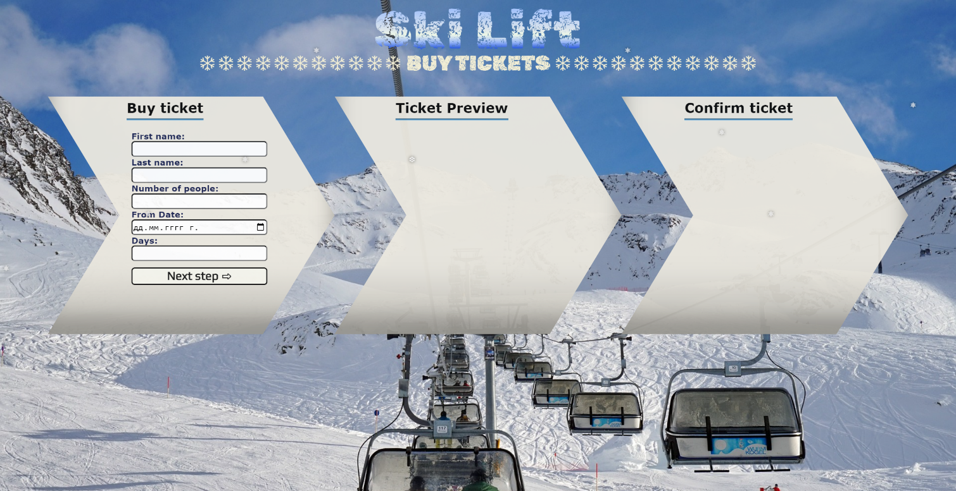**Write the missing functionality** of this user interface. The functionality is divided in the following steps:

**Your Task**

**Write the missing JavaScript code** to make the **Ski Lift** work as expected:

All fields **(First Name, Last Name, Number of people, From date** and **Number of days)** are **filled with the correct input.**

* **First Name, Last Name, Number of people, From date** and **Number of days** are **non**-**empty** **strings.** If any of them is empty, the program should not do anything.

1. **Getting the information from the form**

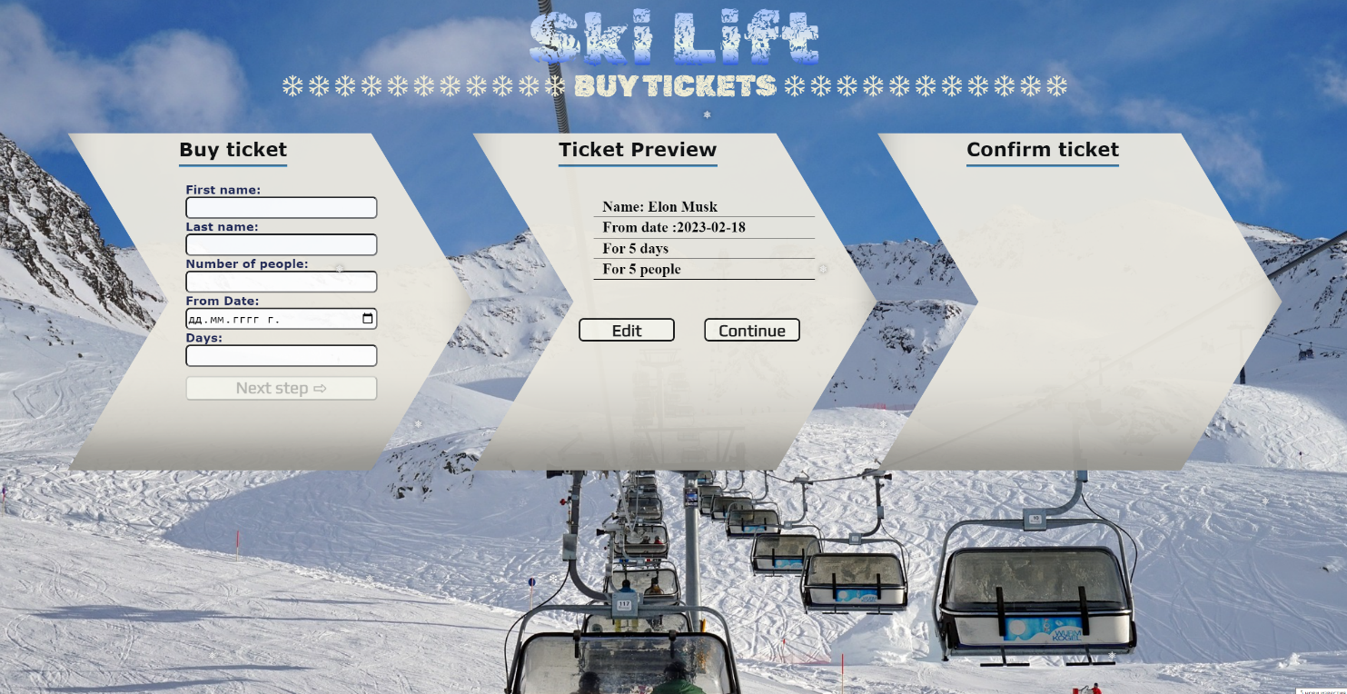

* On clicking the **["Next step"]** button the information from the input fields is listed in the **"info-ticket"** section. For the input fields a **list item** is **added** to the **"** **ticket-info-list"** unordered list.
* The text format and order for the list item should be the same as on the picture below.
* When the button is clicked, the input fields must be cleared and the **["Next step"]** button must be **disabled**. At the same time the **"Edit"** and the **"Continue"** buttons must be **enabled**.

The HTML structure looks like this:

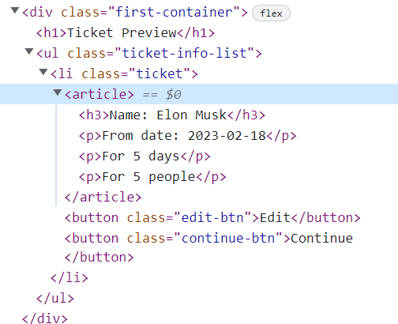

**The functionality here is the following:**

* **When the "Edit" button is clicked, all of the information is loaded in the input fields from step 1 and the ["Next step"] button is enabled again.**

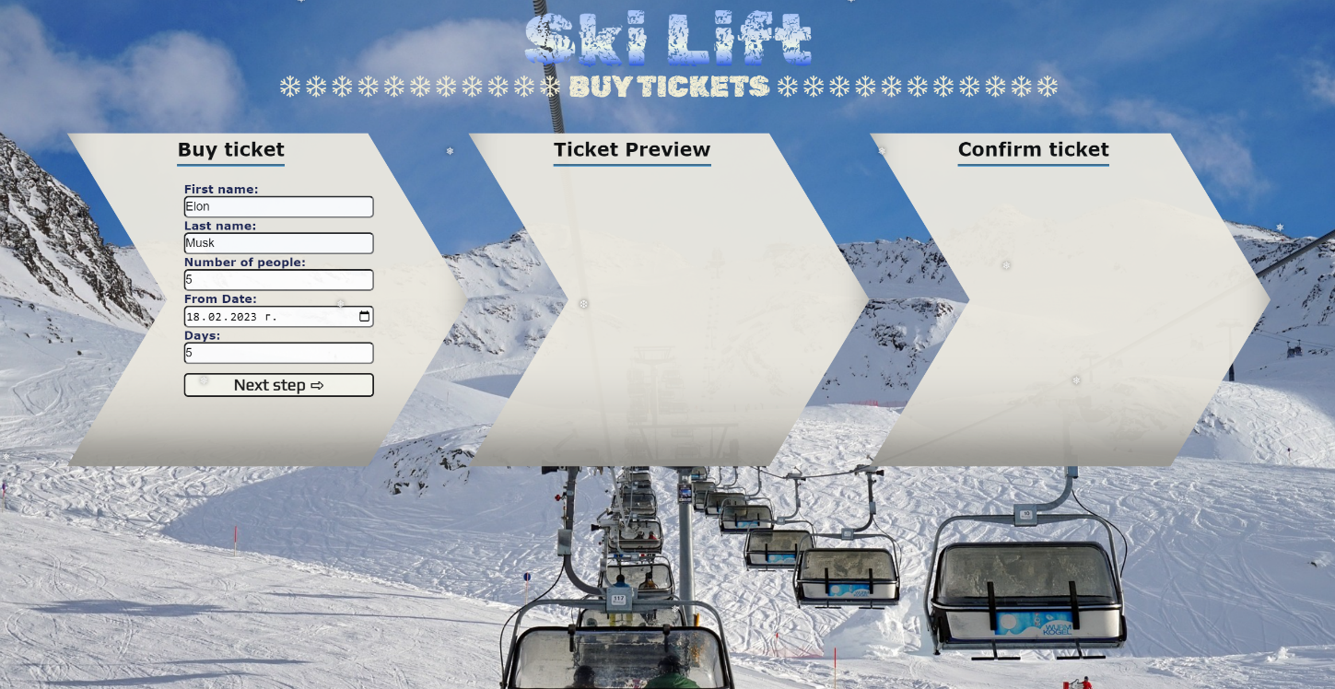

* **The list item must be removed from the " ticket-info-list" and all of the information must go back to the input fields again.**

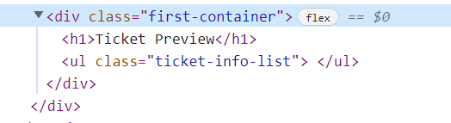

* **When the "Continue" button is clicked,** **the information from "ticket-info-list"** unordered list must be transferred to **"confirm-ticket"** in the **same** HTML structure**. For you, this means removing everything inside of the ul with class "ticket-content " and adding in "confirm-ticket"**, **the list item with same information and class "ticket-info-list" , delete "Edit"** and **"Continue"** buttons and **add** new buttons **"Confirm"** and **"Cancel"** with **class "confirm-btn"** and **"cancel-btn"** .

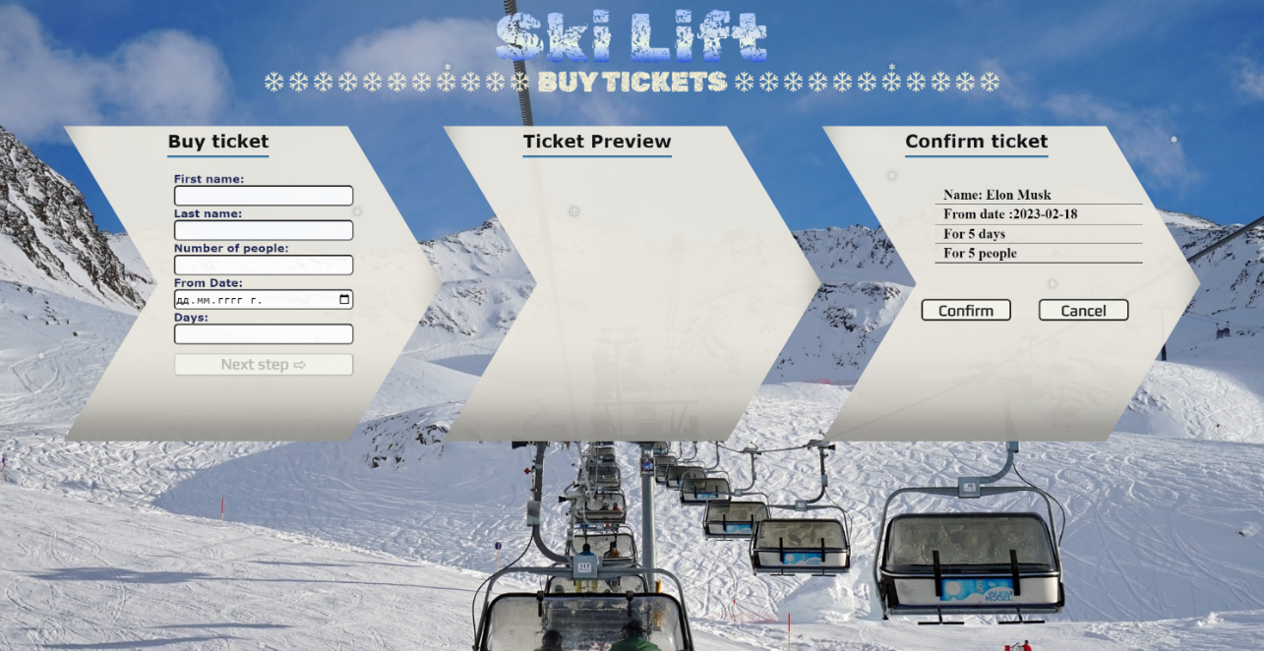

* **This is HTML** structure **of "confirm-ticket"** unordered list**:**

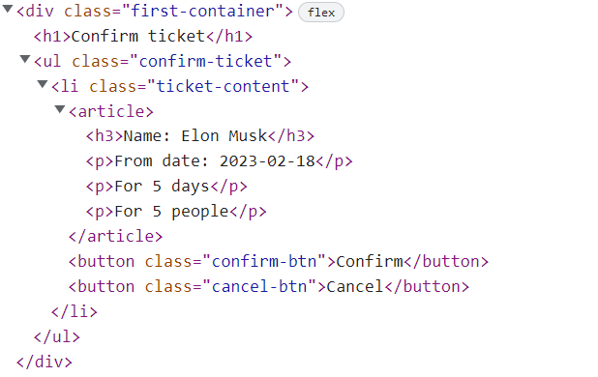

* **When the "Cancel" button is clicked,** **the list item must be removed, from the "confirm-ticket", the ["Next step"] button is enabled again.**

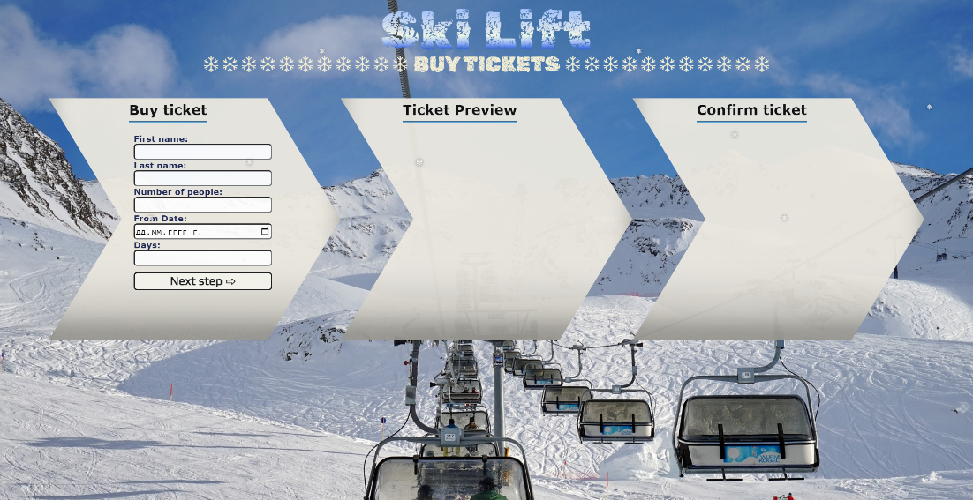

* **When the "Confirm" button is clicked,** **the <div> element with id="main" must be removed, from the body** andyoumust **add <h1>** element with id=**"thank-you"** and **text "Thank you, have a nice day! "** and **<button>** with id=**"back-btn"** and **text "Back ".**



The HTML structure looks like this:

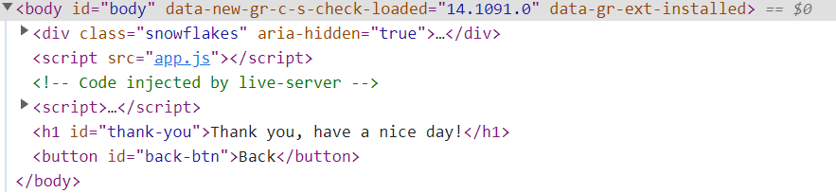

* On clicking the **["Back"]** button you must **reload** the page.

**Submission**

Submit only yours **solution()** function.

*GOOD LUCK… ☺*